

DEPARTMENT OF COMPUTER SCIENCE – UBIT

“Assembly language”

CSSE – 403

Muhammad Suleman

Section ‘A’ (EVENING)

EB23210106101

Submitted to: SIR FAROOQ

ASSIGNMENT-05

**LAB TASK # 05**

**Q**: To understand the concepts of loop and introduce control flow instruction in assembly language.

**INPUT:**

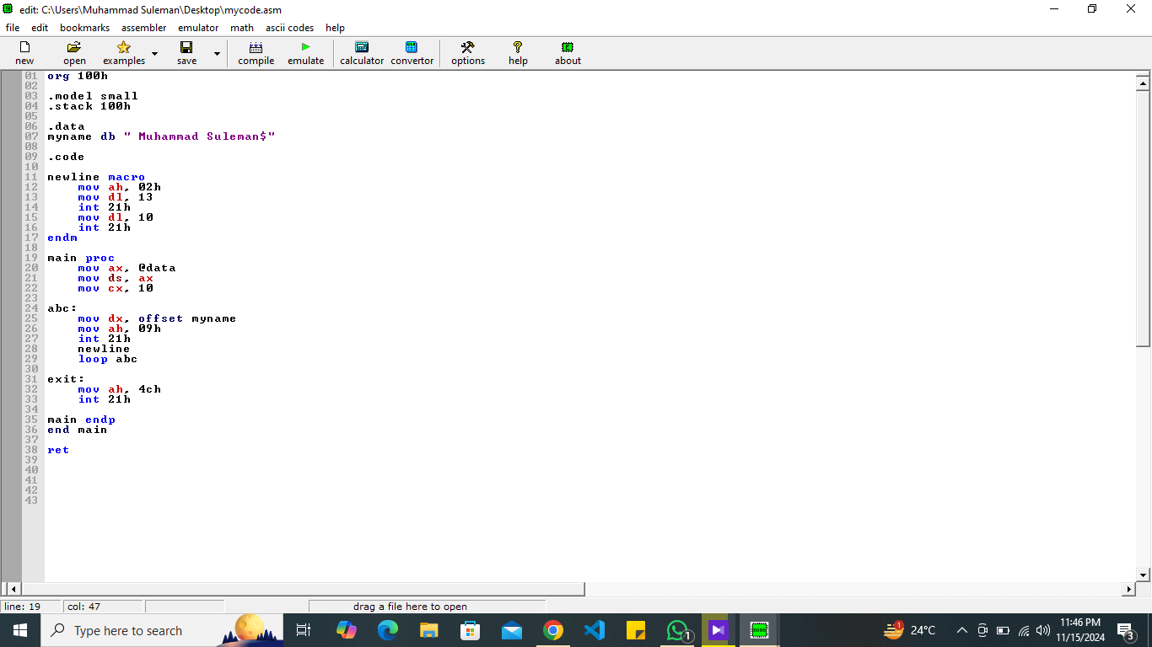

**OUTPUT:**

